Student worksheet

7.8 The half-life of isotopes can be used to tell the time

Pages 148–149 and 221

Radiation

1 Where can radiation or radioactive minerals be found?

2 How can radioactive decay be useful?

3 What is radioactive decay?

4 What is carbon dating?

5 Which is the most abundant carbon isotope?

6 Which carbon isotope is used for carbon dating?

7 Explain why carbon-14 exists in organisms and why it can be used to date them.

8 What is the Shroud of Turin?

9 Why was dating the Shroud of Turin so important?

10 How old did scientists discover the Shroud of Turin to be, and what conclusion could they draw from this?

11 What can carbon dating be used to determine the age of?

12 What is the half life of carbon-14?

13 How long do the following isotopes take to decay?

a lithium-8

b uranium-235

c uranium-238

14 Explain why lithium-8 would not be ideal to date organisms with.

15 Why do scientists determine the radioactive decay of all isotopes in the organism, rather than individual isotopes?

Extend your understanding

16 If scientists predict that the Big Bang occurred over 7 billion years ago, and uranium-238 has a half-life of 4 billion years, why do scientists say that the first half life has only just been reached?

17 A 500g sample of pure carbon-14 was found to contain less than 2g of carbon-14. How long must it have spent in the ground to decay to this mass?

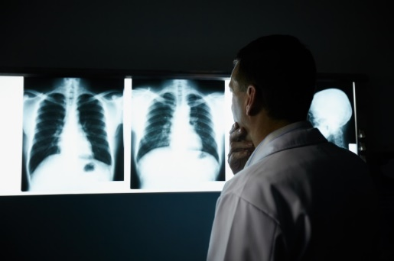Student worksheet

7.9 Radiation is used in medicine

Pages 150–151

Radiation in medicine

1 What is nuclear medicine?

2 Why can radiation be harmful?

3 What effect do free radicals have on the body?

4 How is DNA damaged?

5 What happens to the structure of DNA when it is damaged?

6 What are the potential risks if your DNA becomes damaged?

7 What do you think may be the long-term risks of reproduction if DNA becomes damaged?

8 List and explain 3 ways that radiation can be used in the field of medicine.

9 Do you think that scientists would use the same radioactive material for organ scans as they use for chemotherapy? Explain your answer.

10 Why are X-rays called 'X-ray's? What type of radiation is used?

11 Why is this radiation used and not other types (alpha, beta or gamma)?

Extend your understanding

Radiologists who work with radiation must wear specialised protective equipment.

12 All equipment is made from lead. Why is this?

13 For each piece of equipment in the table below, explain its advantages in terms of radion protection and its disadvantages:

|  |  |  |
| --- | --- | --- |
|  | Advantages | Disadvantages |
| Lead apron |  |  |
| Lead glasses |  |  |
| Lead gloves |  |  |
| Lead masks |  |  |